3D Gun Printing and its Effect on Firearms Examining
By: Lior Nedivi, Independent Firearms Examiner, Advanced Forensic Science Services (AFSS), Jerusalem, Israel
Key words: Class characteristics, Individual characteristics, Liberator pistol, 3D Printing
Introduction
3D gun printing is the "last word" in the world of gun manufacturing and a cause for a debate on its effect on Gun Control. But while people are discussing whether it is right or wrong to "print" a gun without permission or license, we, in the forensic world, need to explore its effect on our work and our ability to solve crimes committed with such a weapon.
3D guns are already a fact we can not ignore or try to block with restricting laws, so what is left is to devise ways of identifying them and connect them to crimes, they same way we did with conventional firearms.

What is 3D printing?
3D printing is a process of making a three-dimensional solid object of virtually any shape from a digital model. 3D printing is achieved using an additive process, where successive layers of material are laid down in different shapes¹.

3D printing and gun making
From the moment 3D printing became a reality and from the second it became available to the general public (at a cost of 8,000$ it is not so expensive), it was only a matter of time till someone will try to manufacture guns, or gun's parts, with it.
It started with a gunsmith who manufactured parts for a conventional firearm (AR15 in 22LR caliber). He replaced most of the body parts (the lower receiver) with plastic ones, living the original barrel, and other metal parts, so they will stand the high pressure of the shots. (Pictures 1&2)
The next step was the manufacturing of a whole gun with 3D printing and I refer of course to the Liberator. Oddly enough, it is based on a cheap pistol from WW2, which was made by the United States military for use by resistance forces in occupied territories. (Picture 3)
Though the original pistol was never, or hardly, used, the new gun was based on it, probably because of its simplicity.
According to the manufacturer, there is only one metallic part in the gun, the firing pin, which is made from a standard nail. (Pictures 4&5)
There are few differences between the two guns, differences that were required because of the change in materials. The barrel of the new Liberator is very thick and the ammunition was changed from 0.45ACP in the original gun to 380ACP in the new one.

The influence on firearms examination
The first influence is on the identification of the gun. Most firearms have their serial number stamped on the frame or on other parts that can easily be replaced by plastic ones. So, instead of seeing firearms with serial numbers scratched, drilled or machined, we will see firearms with no serial number at all.
The second influence is of course on the Class and Individual characteristics of the gun.
There are few questions that need to be answered:
- Are the Class characteristics of multiple guns, printed in the same printer, would be the same?
- Are the Class characteristics of multiple guns, printed in different printers of the same make and model, would be the same?
- Are the Class characteristics of multiple guns, printed in totally different printers, would be the same?
- What kind of Individual characteristics would be left?
- Taking into consideration that in most guns, the gun's parts, which are harder then the ammunition, lives their marks on the ammunition (cartridge and bullet), what will happened in a gun where the ammunition is harder then the gun's parts?
- Besides the firing pin, what other parts, if any, would live marks on the cartridge and bullet?
To answer those questions, some research will have to be done.

What can be done?
If we will accept the fact that 3D printed guns are all ready a fact and that we can not ignore that fact or rely on lawmakers to provide us with laws that would ban such manufacturing (laws that criminals will ignore…), what is left for us to do is to study the new feature and find ways to identify both the weapons and the cartridges and bullets fired from them.
The first step would be to learn whether 3D printers live class and individual characteristics of their own. Our colleagues from questioned documents can tell us how they can identify a certain printer.
The second step would be to test fire some 3D printed guns and study all the marks that are left on them. For example, we can expect that the ammunition would live its impression (head stamp) on the "breach" face.

Conclusions
3D printed guns bring new dimension to the work of firearms examiners, in particular, and forensic science investigations, in general.
We should expect that an investigation of a shooting, conducted by a 3D printed gun, will involve experts of few fields such as tool marks experts, that would have to identify a printer where a certain gun was printed, firearms examiners, that would try to connect between cartridges and bullets to a particular weapon and even forensic computer investigator that would connect between a computer, belongs to a suspect, and a questioned 3D printer.
Bottom line, life of forensic scientists is going to be much more difficult and much more interesting.

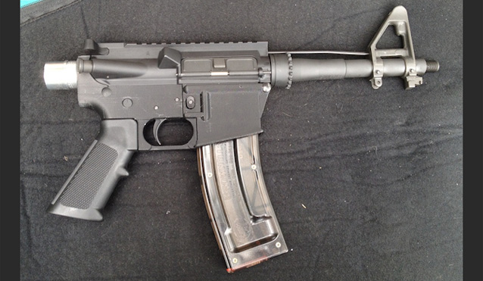
Picture 1 – AR15 with 3D printed parts (Credit: www.extremetech.com)

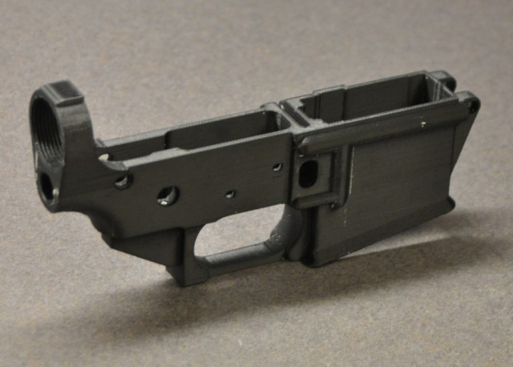
Picture 2- a 3D printed lower receiver (Credit: www.extremetech.com)

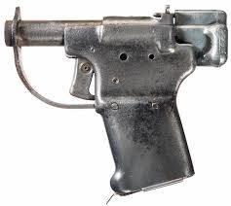
Picture 3 – The FP-45 Liberator

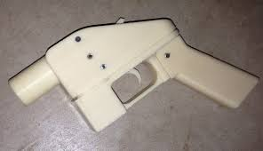
Picture 4 – The 3D Liberator

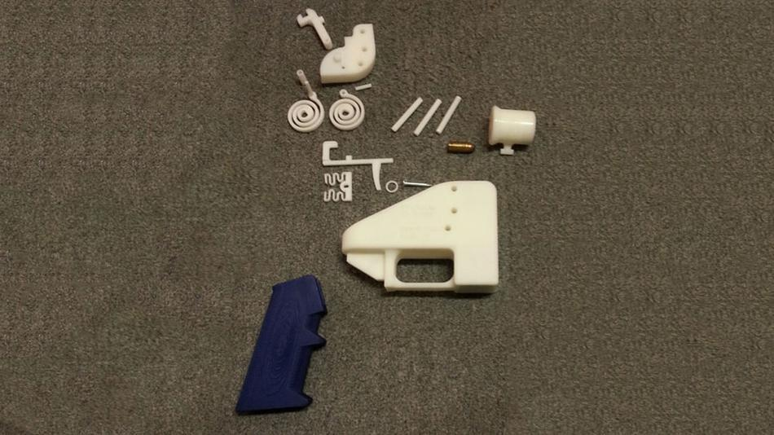
Picture 5 – The 3D Liberator's parts (Credit: Michael Thad Carter for Forbes)
Note the "firing pin" made of a nail

