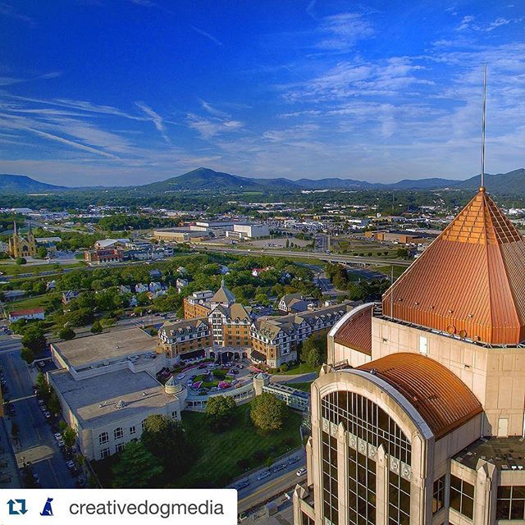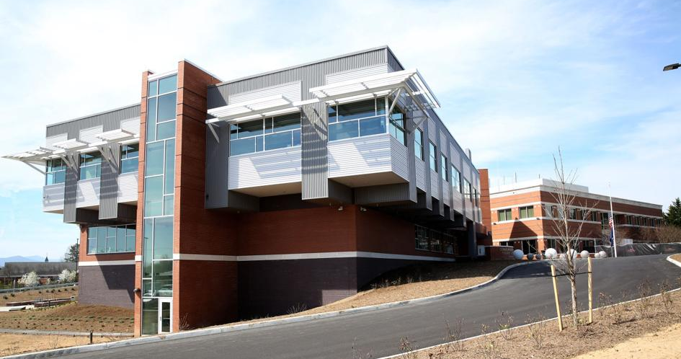
Livability.com released their 2019 100 best places to live with Roanoke, VA on the list at # 85. In 2018 it was ranked #3 of 10 for “Best Affordable”. See why here:
https://livability.com/best-places/top-100-best-places-to-live/2019/va/roanoke
https://livability.com/top-10/families/best-affordable-places-to-live/2018/va/roanoke
The Blue Ridge / Roanoke area is one of the top mountain biking locations in the United States, has many canoe/kayak friendly rivers and lakes, and numerous hiking trails of all levels including a plethora of Appalachian Trail highlights (McAfee Knob is the most photographed AT spot with the trail head a 30 minute drive from downtown).
The city and surrounding area has a wide array of art, theater and restaurants. In Roanoke you will find:
- Roanoke Symphony
- Roanoke Ballet
- Taubman Museum of Art
- Heart of Virginia Wine Trail
- Craft breweries (Soaring Ridge; Ballast Point; Deschutes; Three Notched; many more)
- Weekly farmers markets all summer
- Outdoor festivals and concerts
- Local farm-to-table: Table 50, Local Roots, Blue 5, Pomegranates …

The Virginia DFS system is a state laboratory system with 4 facilities (Richmond, Norfolk, Manassas, Roanoke). It is a full service lab and is currently accredited by ANAB. The firearms section currently consists of 15 examiners, 7 NIBIN examiners, and 2 laboratory specialists state-wide; the Western Laboratory (Roanoke) has 2 examiners and 1 NIBIN examiner.
The Western Lab Firearms section provides each examiner with separate office and laboratory cubicles. Each examiner space is equipped with a Leeds LCF comparison microscope and stereoscope. Examiners are provided a laptop computer with monitor and docking station. The lab also has a firearms reference collection, water recovery shooting tank, single lane range as well as a NIBIN work station. The DFS is beginning to purchase and validate virtual microscopy systems.

